PARTS OF ARGUMENT

Essay Title: “Anthem” Society

Author:

Directions: Correctly identify the parts of the argument for your assigned essay.

1. Claim | Debatable statement that forms the main point of an argument. (Sometimes called a thesis statement.)  What do you think?
2. Reasons | Arguments that help support the main claim.  (These allow you to break a broad claim into smaller, more precise sections.)  Why do you think so?
3. Evidence | Personal experience, outside authorities, facts, and statistics that support subclaims. (Stands by itself; the evidence is not debatable, though its interpretation may be.)  How do you know you’re right?

The three main elements—claims, reasons, and evidence—are the foundation for most academic arguments.

Additional elements:

4.  Acknowledgement and Response | Admission of possible counterarguments, reassertion of your argument. (Strengthens your argument by adding subtleties.)  It may be argued that ____. However, I’m still right because ____. | Acknowledgement:  Response:
5. Warrants | Assumptions that underlie your argument. (Usually left unstated, if you can assume your reader shares them). What am I assuming?
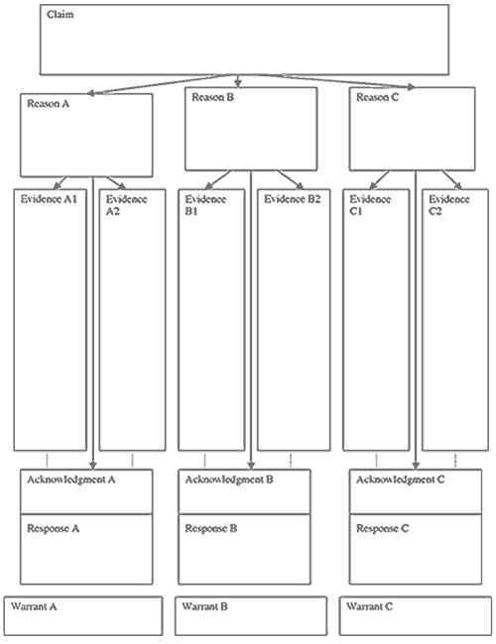
http://faculty.uncfsu.edu/jyoung/argument.htm
http://faculty.virginia.edu/schoolhouse/WP/ArgumentHandouts.html
http://faculty.uncfsu.edu/jyoung/argument.htm
http://writing.colostate.edu/guides/documents/argueparts/

