Irony, Humor, and Double Meanings

Traditional Definition of Irony:
Irony: the discrepancy between what is said and what is meant, what is said and what is done, what is expected or intended and what happens, what is meant or said and what others understand.

Traditional Irony Types:
Situational irony occurs when expectations aroused by a situation are reversed.
Cosmic irony or the irony of fate occurs when misfortune or good fortune is the result of fate, chance, or God.
Dramatic irony occurs when an audience knows more than the characters in the play, so that words and action have additional meaning for the audience.
Socratic irony is named after Socrates' teaching method, whereby he assumes ignorance and openness to opposing points of view which turn out to be (he shows them to be) foolish.

Nontraditional Irony Types:
Cultural irony exists when what is expected within one culture is misunderstood by another culture, or one culture’s expectations are represented in a sarcastic manner.
Visual Irony occurs when a statement about a situation is in contrast to the visual representation. This is close to dramatic irony, but is often used in comedies or cartoons.
Note: Irony, Allusion, and Connotation are the best of friends.

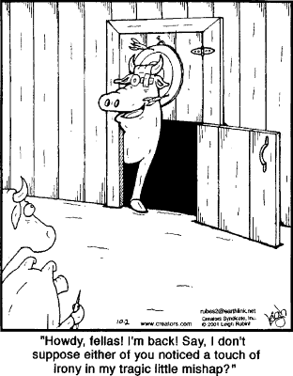

Each of the cartoons possess humor based on the visual, real or imagined, and vocabulary. Explain the basis of the humor using the prompt.
Example:
Animals Playing Darts, page 1.
Prompt: Comment on the cosmic irony as it relates to a common phrase for a perfect dart score.
Answer: The bull’s predicament is a result of chance or cosmic irony and plays on the common phrase “bull’s eye.”

- 

 