I’m Working with Tricky SOL Writing Test Questions—What Should I Do?

Activity Learning Target:

 Today we will create a process for working with challenging multiple choice Writing SOL Test question so that we can build our confidence and develop a plan for test day.

We will know we have it when we can follow these steps without having to look at them:

* Figure out what the question is asking you to do
* Identify the strategy that will help solve the problem
  + Plug it in—verbal or in your head with each answer choice
  + Plug it in—Use scratch paper and write out the answer choices
  + The cross-out technique—for compound subject/predicate, interrupters, pronoun case, etc.
  + Slash the trash/Process of elimination
  + Highlight the differences in each answer choice—Where’s Waldo?
  + Go back to the text
  + Read aloud to yourself
  + Slow down and think!
* Why are you right? Why are the others wrong? Justify!

Passage 1

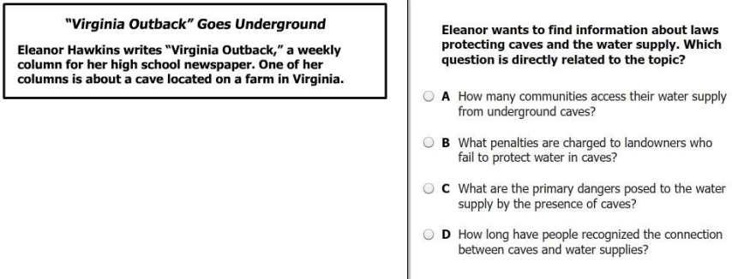

1

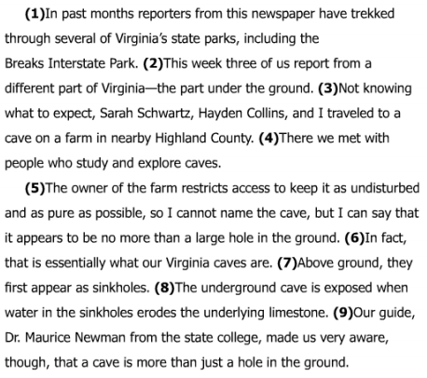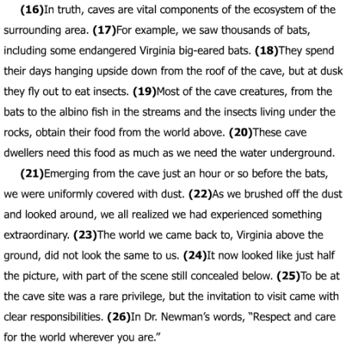

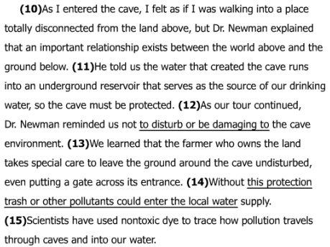

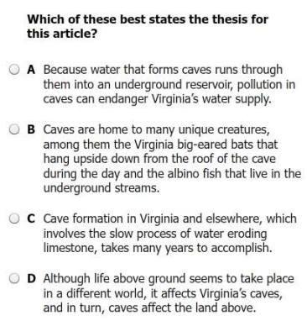 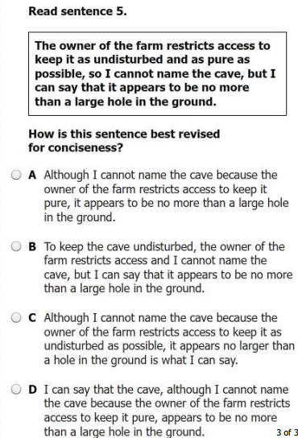

2

3

4

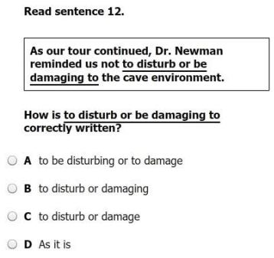 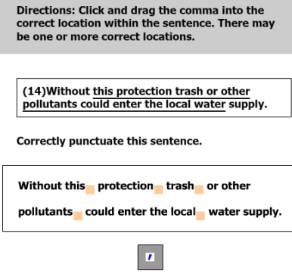

5

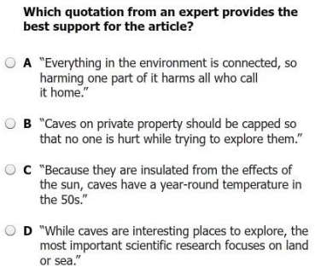 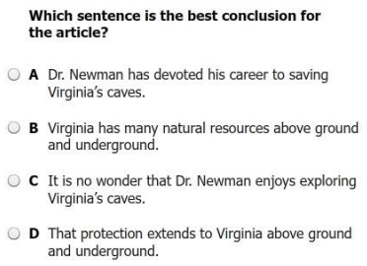

6

7

|  |  |  |  |
| --- | --- | --- | --- |
| **Question/ Answer** | **What did the question ask you to do?** | **What strategy did you use to figure out the answer?** | **Were you right? Why or why not?** |
| **1**  **B** |  |  |  |
| **2**  **D** |  |  |  |
| **3**  **A** |  |  |  |
| **4**  **C** |  |  |  |
| **5**  Without this protection, trash or other pollutants could enter the local water supply. |  |  |  |
| **6**  **A** |  |  |  |
| **7**  **D** |  |  |  |

Passage 2

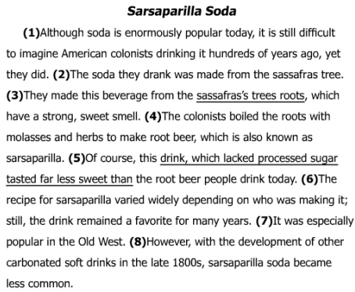 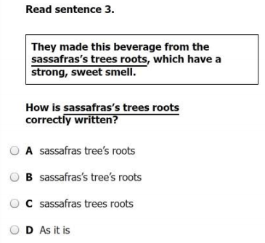

1

2

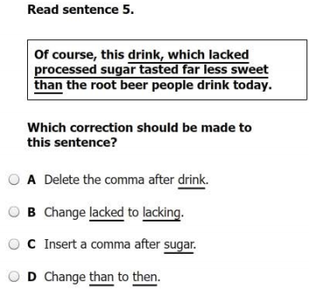 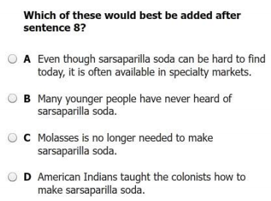

3

|  |  |  |  |
| --- | --- | --- | --- |
| **Question/ Answer** | **What did the question ask you to do?** | **What strategy did you use to figure out the answer?** | **Were you right? Why or why not?** |
| **1**  **A** |  |  |  |
| **2**  **C** |  |  |  |
| **3**  **A** |  |  |  |

Stand Alone Questions

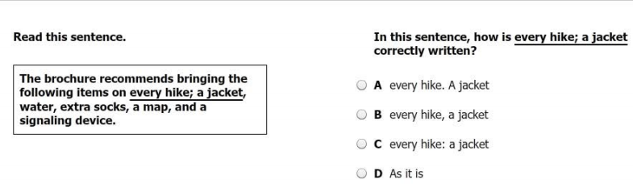

2

1

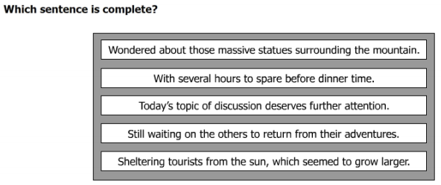

|  |  |  |  |
| --- | --- | --- | --- |
| **Question/ Answer** | **What did the question ask you to do?** | **What strategy did you use to figure out the answer?** | **Were you right? Why or why not?** |
| **1**  **C** |  |  |  |
| **2**  3RD—“Today’s topic…” |  |  |  |

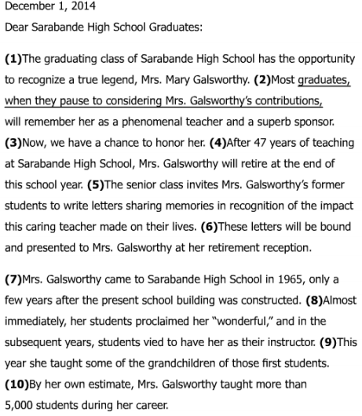

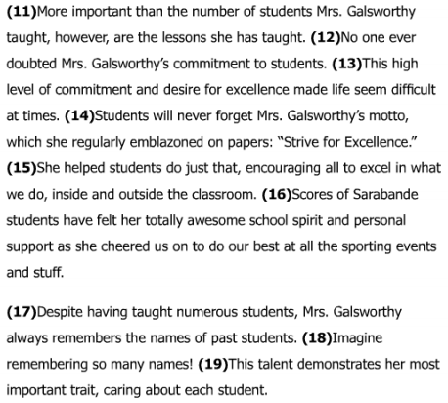

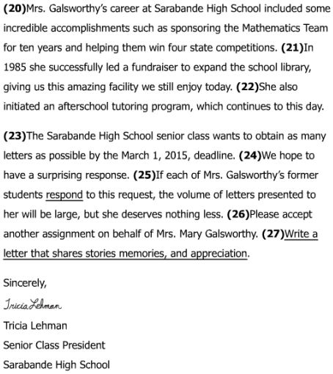

Passage 3

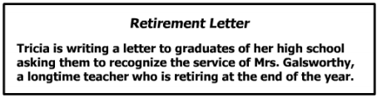

1

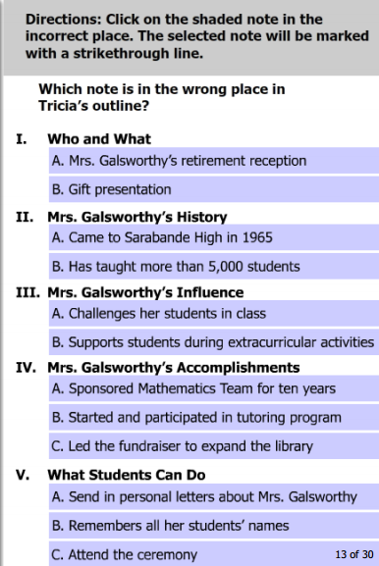

2

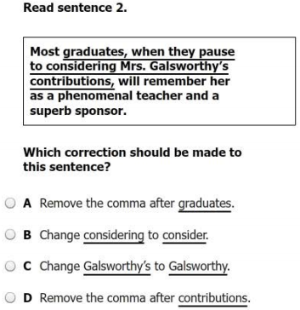

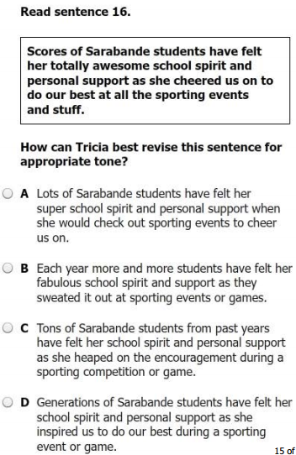 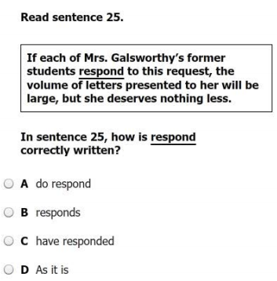

3

4

5

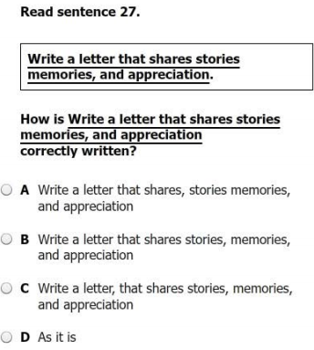 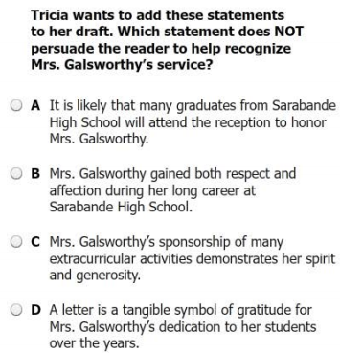

6

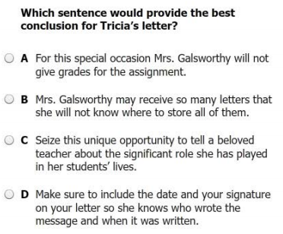

7

|  |  |  |  |
| --- | --- | --- | --- |
| **Question/ Answer** | **What did the question ask you to do?** | **What strategy did you use to figure out the answer?** | **Were you right? Why or why not?** |
| **1**  **V. B.**  “Remembers…” |  |  |  |
| **2**  **B** |  |  |  |
| **3**  **D** |  |  |  |
| **4**  **B** |  |  |  |
| **5**  **B** |  |  |  |
| **6**  **A** |  |  |  |
| **7**  **C** |  |  |  |

Passage 4

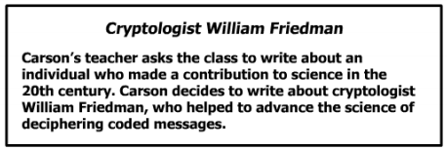

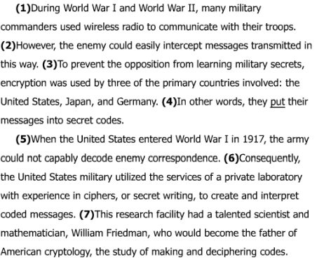

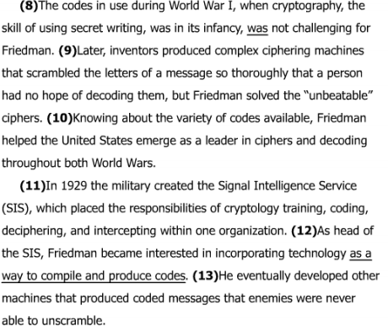

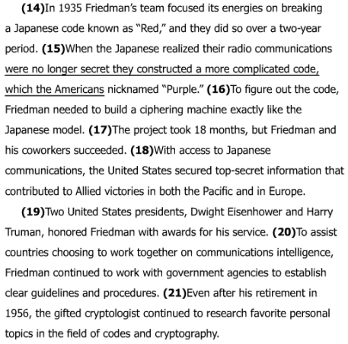

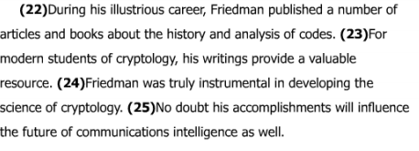

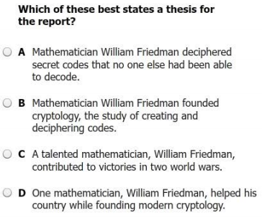

1

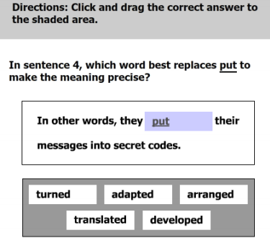 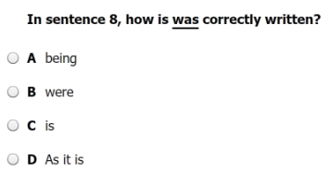

2

3

5

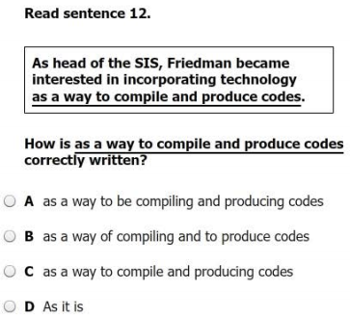 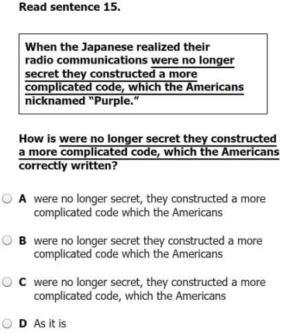

6

4

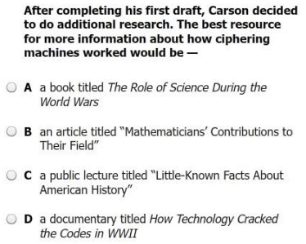

|  |  |  |  |
| --- | --- | --- | --- |
| **Question/ Answer** | **What did the question ask you to do?** | **What strategy did you use to figure out the answer?** | **Were you right? Why or why not?** |
| **1**  **D** |  |  |  |
| **2**  translated |  |  |  |
| **3**  **B** |  |  |  |
| **4**  **D** |  |  |  |
| **5**  **C** |  |  |  |
| **6**  **D** |  |  |  |

Passage 5

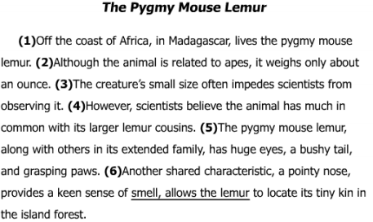

**2**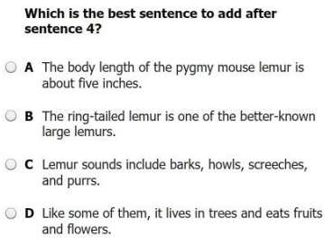

1

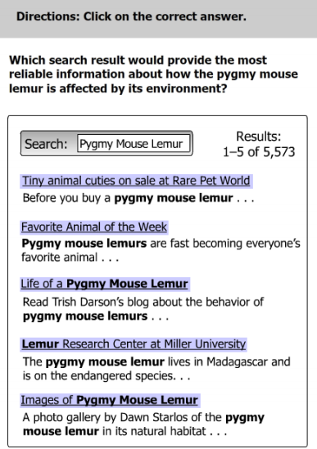

**3**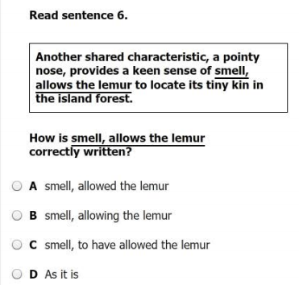

|  |  |  |  |
| --- | --- | --- | --- |
| **Question/ Answer** | **What did the question ask you to do?** | **What strategy did you use to figure out the answer?** | **Were you right? Why or why not?** |
| **1**  4TH **“Lemur**  Research…” |  |  |  |
| **2**  **D** |  |  |  |
| **3**  **B** |  |  |  |

Passage 6

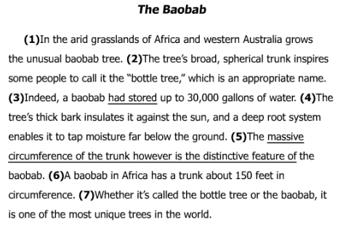 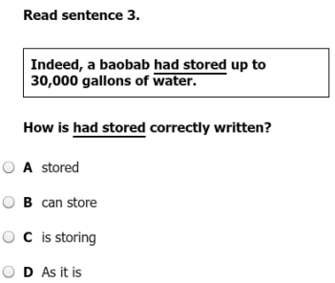

1

2

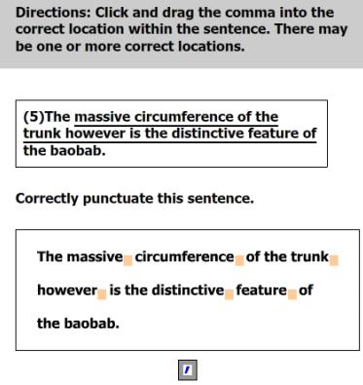

|  |  |  |  |
| --- | --- | --- | --- |
| **Question/ Answer** | **What did the question ask you to do?** | **What strategy did you use to figure out the answer?** | **Were you right? Why or why not?** |
| **1**  **B** |  |  |  |
| **2**  The massive circumference of the trunk, however, is the distinctive feature of the baobab. |  |  |  |